Chapter 3

Methodology
Sections 3.1 to 3.9 — one figure, seven tables, seven equations.

3.1 Research Design and Overview of the Proposed Method
This chapter specifies the forecasting method: the data it requires, how each component is built, how its parameters are chosen, and how the forecasts are judged. It is written to be reproducible by a reader who has not seen the implementation and to apply to any dataset meeting Section 3.2's requirements; the values these procedures return belong to Chapter 4.
The paradigm is a controlled comparative evaluation. Chapter 2 found the gap here to be one of integration rather than invention, the econometric, regime-switching, deep-learning and uncertainty-quantification traditions having matured separately. The object under test is therefore the assembled pipeline, not a novel architecture: all models forecast the same target over the same window, on the same losses and tests, and only the component under examination varies. Each research question concerns a different property of the predictive distribution — RQ1 the conditional mean, judged on point loss; RQ2 whether that loss depends on the market state, judged on conditional predictive ability; RQ3 the interval, judged on coverage, sharpness and proper scoring rules.
Figure 3.1 shows the pipeline, Sections 3.2 to 3.7 taking its stages in order. The target is realised variance rather than realised volatility, every loss computed on the variance scale, and Table 3.1 fixes each model's role. A single primary asset is evaluated, a scope decision revisited in Section 3.9. The study uses only aggregate published data, so there are no human participants; but volatility forecasts inform capital decisions, so an over-confident interval is not a neutral error, which is why RQ3 tests calibration rather than assuming it.
Table 3.1 Model inventory: the role each model plays in the comparison.
Term | Role in this study
Econometric baseline | GARCH(1,1), EGARCH, HAR-RV. Established models the approach must clear; each isolates one competing explanation (Table 3.3).
Reference floor | A random walk in variance. Not a baseline: the accuracy persistence alone attains.
Unconditional network | An LSTM receiving no regime information. The control.
Regime-conditioned network | An LSTM receiving the state posterior, by either architecture in Section 3.4.
Regime signal | The per-day distribution over states from Section 3.3, using forecast-origin information only.
Ablation | A specification removing one component to attribute an effect, not to compete.
Headline / comparator profile | The pipeline on the jump-penalised state estimator (pre-registered), and re-run on a maximum-likelihood one to test estimator dependence.
Table 3.1. The terms in the left-hand column are used with these meanings in every subsequent chapter.
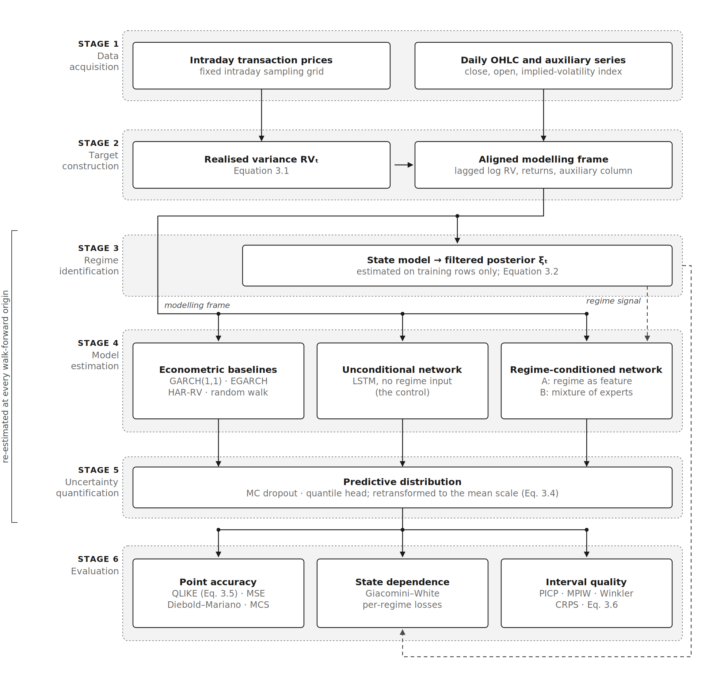
Figure 3.1. The forecasting pipeline. Solid arrows carry data; the dashed arrow carries the regime signal, estimated on the training window only.

3.2 Data Requirements
The method is specified against a data interface, not a data source: any series meeting the requirements below drives the pipeline unchanged, and Chapter 4 names the series used. The dependent variable is the daily realised variance, formed from intraday prices as the sum of squared intraday returns:
RV_{t} = Σ_{i=1}^{M} r_{t,i}² , r_{t,i} = log P_{t,i} − log P_{t,i−1} (3.1)
where P_{t,i} is the i-th price on day t on a fixed grid of M intervals, r_{t,i} the corresponding intraday log return, and RV_{t} the realised variance of day t, which converges to integrated variance as the grid is refined (Andersen et al., 2003). The grid must be fixed and documented, not of any particular width: a finer grid lowers discretisation error but admits more microstructure noise, five minutes being the conventional compromise (Liu, Patton and Sheppard, 2015). The target must be strictly positive, the models being estimated on its logarithm under a ratio loss, and it is a variance rather than a standard deviation, the two not being interchangeable under a non-linear loss.
Predictor requirements stay modest, the comparison in Section 3.4 being interpretable only if every model draws on the same information set. Table 3.2 gives the interface; an auxiliary implied-volatility series must price options on the same market as the target, one from another market being a spillover experiment rather than a feature. Rows with a missing value in a required field are dropped, never imputed, the missing quantity being the object forecast.
Table 3.2 Data dictionary: what the method requires of any input series.
Field | Type | Status | Constraint | Purpose
date | date | Required | Unique, ascending, trading days | Join key for all sources
Intraday prices, or a realised measure | float | Required | Fixed documented grid; positive | Forecast target RV_{t} (Eq. 3.1)
close | float | Required | Positive | Close-to-close return for the variance baselines
open | float | Optional | Positive; session-only measures | Open-to-close return, matched to the target
Implied volatility | float | Optional | Positive; same market as the target | Auxiliary input for the Section 3.4 ablation
rv_{d}, rv_{w}, rv_{m} | float | Derived | 1-, 5-, 22-day means of RV_{t} | HAR predictors (Corsi, 2009)
log RV_{t} | float | Derived | Finite | The scale every network is estimated on
Table 3.2. Data dictionary: what the method requires of any input series.
Minimum history: 22 + L trading days of warm-up (the monthly HAR aggregate plus the network lookback), then training, validation and test windows as specified in Section 3.6.

3.3 Regime Identification
This stage produces the regime signal of Table 3.1: for every trading day, a distribution over K latent market states formed without reference to the future. Three requirements shape the estimator — unsupervised, since no labelled regimes exist; persistent, since a signal changing every few days injects noise into anything conditioned on it; and causal at the point of use. The standard instrument, a Gaussian-emission hidden Markov model estimated by maximum likelihood (Hamilton, 1989), fails the second: expectation-maximisation switches states faster than the data warrant (Nystrup, Lindström and Madsen, 2020). This design adopts their remedy, penalising switching directly, and keeps the maximum-likelihood fit as the comparator profile. Over the state path {s_{t}} and parameters {θ_{k}}, it minimises
Σ_{t=1}^{T} ℓ(x_{t}, θ_{sₜ}) + λ Σ_{t=2}^{T} 1{s_{t} ≠ s_{t−1}} (3.2)
where x_{t} is the standardised feature vector on day t, s_{t} ∈ {1, …, K} its state, θ_{k} the Gaussian mean and covariance of state k, ℓ the Gaussian negative log-likelihood, 1{·} the indicator and λ ≥ 0 the penalty charged whenever the state changes. The penalty carries the argument: at λ = 0 the objective is atemporal clustering, and as λ grows the fit buys persistence at the cost of responsiveness. Coordinate descent minimises it; the resulting path then serves as a route to an HMM, whose forward filter yields a posterior P(s_{t} | x₁, …, x_{t}) carrying the confidence the mixture of Section 3.4 needs. Causality is enforced at three points: the state model sees training rows only, the posterior used downstream is filtered rather than smoothed, and the signal is lagged one day wherever it enters a forecasting model.
Likelihood cannot select the penalty, always preferring λ → 0 and so returning the pathology it exists to remove. Selection applies a stated rule to a stated grid — the smallest λ whose mean regime duration clears a persistence floor, on training rows only — with grid, floor and rule fixed before any downstream result existed, which prevents the penalty being tuned to the answer; a finer sweep is published alongside so the grid's influence is visible.

3.4 Model Specification
What varies across the models of Table 3.1 is the information each may use and the form each may take, and only one varies at a time. Three econometric baselines close off a different competing explanation apiece, alongside a reference floor; Table 3.3 states what each rules out.
Table 3.3 The baseline set and what each is there to rule out.
Model | Source | What it rules out | Role
GARCH(1,1) | Bollerslev (1986) | That a return-driven variance recursion already suffices | Baseline
EGARCH(1,1,1) | Nelson (1991) | That the gain is the leverage asymmetry the symmetric model omits | Baseline
HAR-RV | Corsi (2009) | That linear long memory is all the problem needs — the benchmark to beat | Baseline
Random walk in variance | — | Nothing: it measures persistence alone | Reference floor
Table 3.3. The baseline set. The conditional-variance models take open-to-close returns, matching the session-only realised measure; a close-to-close return embeds the overnight gap, which the ratio loss of Section 3.7 would read as forecast error.
The deep architecture is a long short-term memory network (Hochreiter and Schmidhuber, 1997), retained for the reasons given in Chapter 2: gated recurrence imposes a strong temporal inductive bias suited to the modest effective sample sizes of daily financial data. The alternative was attention — the Transformer (Vaswani et al., 2017) and the Temporal Fusion Transformer (Lim et al., 2021) — rejected on evidence rather than conservatism. Attention is data-hungry, precisely the regime in which a strong inductive bias is most valuable (Lim and Zohren, 2021), and recent benchmarks find simple recurrent models matching elaborate transformers (Zeng et al., 2023). The claim is not that attention cannot work here, but that at this sample size it is the weaker prior. Each network passes a window of the previous L trading days through one recurrent layer to a linear output, estimated by mean squared error on standardised log realised variance.
Two architectures condition that network on the regime signal, differing in where it enters. Regime as feature appends the lagged posterior to the input vector. A mixture of experts (Jacobs et al., 1991) trains one network per state and recombines their forecasts by the posterior acting as a soft gate:
ŷ_{t} = Σ_{k=1}^{K} g_{k,t} f_{k}(x_{t−L:t−1}) , g_{k,t} = P(s_{t−1} = k | x₁, …, x_{t−1}) (3.3)
where f_{k} is the k-th expert, x the input window of L days ending at t−1, and g_{k,t} the gate weight on expert k for day t, taken as the filtered posterior of Section 3.3 at t−1, which makes the mixture causal. Crucially the signal enters only through the gate, so the experts see exactly what the unconditional network sees: the first architecture varies the information and fixes the form, the second the reverse.
Every model estimated in logs needs one further step, exponentiating a fitted conditional mean returning a median while the losses of Section 3.7 are defined for a mean:
RV_{t|t−1} = exp(μ̂_{t} + ½ σ̂²) (3.4)
where RV_{t|t−1} is the forecast of RV_{t} formed at t−1, μ̂_{t} the fitted conditional mean of log realised variance, and σ̂² the variance of the log residuals on a held-out training tail. The correction is exact under Gaussian residuals; Duan's (1983) non-parametric smearing estimator is the alternative, buying robustness at the cost of retaining a residual sample. It applies to every model forecasting in logs, selective application biasing the comparison.

3.5 Uncertainty Quantification
RQ3 asks whether a forecast's stated uncertainty can be trusted, requiring each model to emit a predictive distribution rather than a number. Two approaches dominate, on incompatible foundations: an approximate-Bayesian method treating the weights as uncertain, and a distribution-free method estimating quantiles directly. Both are implemented, a calibration result holding under only one of them being a result about that method rather than about the pipeline.
The primary method is Monte Carlo dropout (Gal and Ghahramani, 2016). Training is unchanged from Section 3.4, so the fitted weights are the point model's and the method adds uncertainty rather than a different forecast; only inference changes, the dropout staying active while the network runs T stochastic passes. Reusing the point model keeps the comparison clean: a difference in interval quality cannot then be a difference in the forecaster. Those passes and the residual term of Equation 3.4 supply two components of predictive variance, which add:
μ̂_{t} = (1/T) Σ_{j=1}^{T} m_{t,j} , σ̂_{t}² = (1/T) Σ_{j=1}^{T} (m_{t,j} − μ̂_{t})² + σ̂² (3.5)
where m_{t,j} is the log-variance output of the j-th pass on day t, μ̂_{t} the predictive mean, the first term the epistemic variance and σ̂² the aleatoric variance from held-out residuals. The distinction matters for RQ3: epistemic uncertainty should shrink as data accumulates and widen where the model extrapolates, aleatoric uncertainty should not, and an interval omitting either is miscalibrated for a different reason.
The comparison method assumes no distribution: one network carries a multi-quantile head trained under the pinball loss (Koenker and Bassett, 1978), monotone by construction so quantiles cannot cross. That decides how it may be scored, a median head estimating a conditional median whereas the losses of Section 3.7 are defined for a mean, which on a right-skewed target differ systematically; its own quantiles identify a log-normal law, which Equation 3.4 converts. A third specification, the same network's deterministic forecast with an aleatoric-only interval, is an ablation isolating what the passes buy. Hyperparameters stay at the Section 3.6 values throughout.

3.6 Training Protocol and Parameter Selection
The data are split by time into three contiguous blocks — training, validation and test — not by random folds. Cross-validation assumes exchangeable observations; volatility is strongly autocorrelated, so a randomly held-out day sits between two the model has seen and is predictable from them alone. The validation block carries every selection decision; the test block is touched once. Over it the models are re-estimated on an anchored walk-forward, the training window growing from the start of the sample, which beats a fixed-length rolling window because volatility regimes recur and discarding an early crisis would leave the model with no instance of the behaviour it most needs to have seen.
Free quantities are chosen by exhaustive grid search, each combination trained on the training block and scored on the validation block. Grid search beats random or Bayesian search here, whose advantages accrue in high-dimensional spaces where a few parameters dominate (Bergstra and Bengio, 2012); with three parameters the grid is small enough to enumerate, so every candidate and its score can be reported and the choice is auditable rather than asserted.
Table 3.4 Hyperparameters: meaning, candidates, selection and expected effect.
Hyperparameter | What it controls | Candidates | Selection | Expected effect of increasing it
Lookback L | Days per input window | 3 values, 10–40 | Grid, validation loss | Captures slower dynamics but dilutes recent information, which for volatility is the most informative
Hidden width | Recurrent-state capacity | 3 values, 32–128 | Grid, validation loss | Fits richer non-linearity; overfits sooner, bounded by early stopping
Learning rate | Optimiser step size | 2 values, 1e-4 to 1e-3 | Grid, validation loss | Converges faster but may overshoot; smaller needs more epochs
Recurrent layers | Depth | Fixed at 1 | Not swept | Adds capacity the sample cannot identify
Dropout rate | Regularisation, and the source of the Section 3.5 passes | Fixed | Not swept — deliberately | Regularises harder and widens the interval, so tuning it on point loss would tune interval width too
Early-stopping patience | Epochs without improvement before halting | Fixed | Not swept | Permits further fitting, raising overfitting risk
Gradient-clip norm | Per-update gradient ceiling | Fixed | Not swept | Loosens a stability guard
Weight decay | L2 penalty | Zero | Not swept — deliberately | Would make dropout's and early stopping's contributions unattributable
Table 3.4. Hyperparameters. Selected values are reported in Chapter 4, being outcomes of the procedure.
One unswept decision in Table 3.4 is substantive: the dropout rate is fixed because it also generates the stochastic passes of Section 3.5, so tuning it on point loss would silently tune interval width, letting RQ1's selection decide RQ3's answer. Early stopping monitors a time-ordered tail rather than a random subset, shuffling reintroducing the leakage the outer split prevents.
Leakage discipline is enforced at three further points: standardisers are fitted on training rows only, every input window ends strictly before the date it predicts, and each fold's training window ends the day before its first forecast. With the three Section 3.3 imposes, no quantity entering a forecast for day t was computed with knowledge of any observation dated t or later. The selected architecture is then held fixed for every variant, re-searching each confounding a component's effect with that of a fresh search.

3.7 Evaluation Design
Every model is scored on the same held-out block and dates, used once, so the losses are paired as the significance tests require. Table 3.5 lists the criteria and the question each answers; most are conventional and used conventionally, so they are named and cited rather than re-derived, while two depart from standard practice and are defined below.
Table 3.5 Evaluation criteria and the question each answers.
Criterion | What it establishes | RQ | Source
QLIKE (primary) | Point accuracy, ranking consistently despite an imperfect proxy | 1, 2 | Patton (2011); Eq. 3.6
MSE (secondary) | Point accuracy under a different weighting of large errors | 1 | Patton (2011)
MAE (descriptive) | Absolute error; never used to rank, lacking proxy robustness | — | —
Diebold–Mariano | Whether a difference in average loss is significant, with HAC variance, a finite-sample correction and a Student-t reference | 1 | Diebold and Mariano (1995); Newey and West (1987); Harvey, Leybourne and Newbold (1997)
Giacomini–White | Whether the better model is predictable from the state known at t−1 — RQ2 as a hypothesis | 2 | Giacomini and White (2006)
Model Confidence Set | The set indistinguishable from the best, controlling family-wise error at once | 1 | Hansen, Lunde and Nason (2011); Politis and Romano (1994)
PICP and MPIW | Interval coverage and width, read as a pair | 3 | —
Winkler score; CRPS | The coverage–sharpness trade-off in one proper score | 3 | Gneiting and Raftery (2007)
Kupiec; Christoffersen; dynamic quantile | Whether violations match the nominal rate, cluster, or are predictable at t−1 | 3 | Kupiec (1995); Christoffersen (1998); Engle and Manganelli (2004)
Difference in coverage | Whether a subsample's violation rate differs from the rest | 3 | Project-specific; Eq. 3.7, Holm (1979)
Table 3.5. Evaluation criteria. The two departing from standard practice are defined in Equations 3.6 and 3.7.
The primary point loss is QLIKE, and the choice is not stylistic: realised variance is a proxy for an unobservable quantity, and Patton (2011) shows that under an imperfect proxy most loss functions rank models inconsistently. QLIKE is in the restricted class that does not, and it penalises under-prediction more heavily than over-prediction, matching the asymmetric cost Chapter 1 identifies.
QLIKE = (1/n) Σ_{t=1}^{n} [ σ_{t}² / h_{t} − log ( σ_{t}² / h_{t} ) − 1 ] (3.6)
where σ²_{t} is the realised variance on day t and h_{t} the variance forecast for it. QLIKE is more often written without the final two terms; this form subtracts its value at a perfect forecast, so the loss is zero when h_{t} = σ²_{t}. It is a Bregman divergence, not a different loss — every ranking and test statistic is unchanged — but a reported number becomes readable as a distance from perfect.
The second departure concerns subsample coverage. A model under-covering globally fails a nominal-level test on every subsample with power, so a rejection there is evidence about its overall level rather than about the subsample, and reading it otherwise attributes a level failure to timing. The quantity isolating a subsample is the difference in violation rates between it and the rest:
hit_{t} = 1{ y_{t} < ℓ_{t} or y_{t} > u_{t} }
Δ = E[hit_{t} | g_{t} = 1] − E[hit_{t} | g_{t} = 0] (3.7)
where y_{t} is the realised variance, ℓ_{t} and u_{t} the interval bounds, g_{t} a subsample indicator measurable at t−1, and Δ the difference in violation rate between flagged days and the remainder, tested as the coefficient on g_{t} in a regression of the hit on the indicator with a Newey–West HAC variance, a regime indicator being persistent by construction; the family then takes the Holm correction (Holm, 1979). Coverage and width are reported together, and both tails separately as well as pooled, pooling letting a band too narrow above and too wide below pass on net.

3.8 Computational Requirements and Reproducibility
This section states what the method requires of a machine rather than what it happened to run on. The requirement is modest by design, Section 3.4 arguing that inductive bias suits a sample of this size better than capacity does; deployment is smaller still, so the operational constraint is the availability of the daily realised measure rather than computation.
Table 3.6 Minimum computational requirements.
Resource | Requirement | Basis
Trainable parameters | 203,139 (largest) | Mixture of experts, K = 3; unconditional network 67,713
Model size | ≈ 0.8 MB | Single precision
Training data in memory | < 1 MB | ~5,500 daily rows
Accelerator | None | CPU throughout
End-to-end runtime | Under 15 minutes | Measured; hyperparameter search and tests included
Inference | One forward pass per day | The binding cost is input data, not computation
Table 3.6. Minimum computational requirements, derived from the architectures of Section 3.4.
Reproducibility rests on four measures: every stochastic component is seeded, including the dropout masks generating the intervals of Section 3.5; every dependency is pinned in a lock file; one script regenerates every artefact in dependency order; and outputs are written to a versioned directory treated as the source of truth. Pinning is not a formality — rebuilding an artefact under a different interpreter version was found to disagree materially with the committed one, a discrepancy indistinguishable from outside from an error in the method.

3.9 Threats to Validity and Mitigation
A design is only as credible as its account of what could undermine it. Table 3.7 sets out the threats, the mitigation adopted for each, and what remains; some are closed structurally, while others are only bounded or declared, and those constrain what the results may be taken to show.
Table 3.7 Threats to validity, mitigation, and residual risk.
Threat | Mitigation | Residual risk
Proxy error: realised variance estimates an unobservable | Proxy-robust losses only (Section 3.7); grid fixed and documented | Coverage is measured against the proxy, not the latent variance
Look-ahead leakage | Six structural controls across Sections 3.3 and 3.6 | Closed by construction; none identified
Regime labels are estimated | The pipeline is re-run on an independent state estimator (Section 3.3) | Both share a Gaussian-emission family; dependence on that family stays hidden
One stress episode dominates the window | Results broken out by state and tested conditionally | The crisis subsample is small, so its tests are weak
Multiple comparisons | Model Confidence Set across models; Holm across the coverage family | —
Researcher degrees of freedom | Penalty grid, floor and rule fixed before any result existed; sensitivity sweep published | The feature set and state-count grid were not pre-registered to the same standard
Single-seed training | Every stochastic component seeded and reported | Reproducible is not robust: a small gap could be initialisation
A single market and frequency | Declared in advance; depth preferred to breadth | Generalisation untested; Chapter 5 returns to it
Table 3.7. Threats to validity, mitigation, and residual risk.
Two shape interpretation most. Every loss, interval and test is computed against realised variance, an estimate of an unobservable, so a coverage figure describes how often the interval contains the proxy and not the truth. And a single stress episode dominates the out-of-sample window, so results are broken out by state rather than pooled. What this design can establish is therefore bounded: under this protocol, on this market and window, it can determine whether regime conditioning and an uncertainty layer improve forecasts against baselines chosen to close off the competing explanations — but not that those findings transfer elsewhere.

